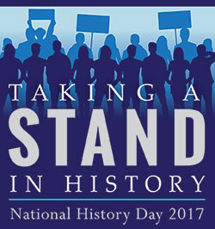

National History Day Contract

Researcher Agreement

I, ________________________, have decided to study______________ _________________________ for my National History Day project. This topic connects to the NHD theme of Taking a Stand in History because ______________________________________________________________________________________________________________
______________________________________________________________________________________________________________

I will be working _____ individually
_____ in a group – My partner(s) will be: _______________ _________________ _________________

Student Signature__________________________

Partner Agreement

I have agreed to work with this student on the NHD project. I will complete my fair share of the research and project development and will share in any costs incurred during the development of the project.

Partner Signature(s)__________________________
__________________________
__________________________

Parent/Guardian Agreement

I have reviewed the philosophy, expectations, and timetable of National History Day work with my son/daughter. I support my son’s/daughter’s decisions regarding the National History Day topic, partner and type of project.

Parent Signature___________________________

*Students who wish to make changes to their topic, partner, or type of project must complete and submit a new contract.

